35.25: a) To the first maximum: 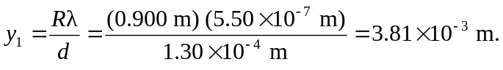
So the distance to the first minimum is one half this, 1.91 mm.

b) The first maximum and minimum are where the waves have phase differences of zero and pi, respectively. Halfway between these points, the phase difference between the waves is 